**Plant Life**

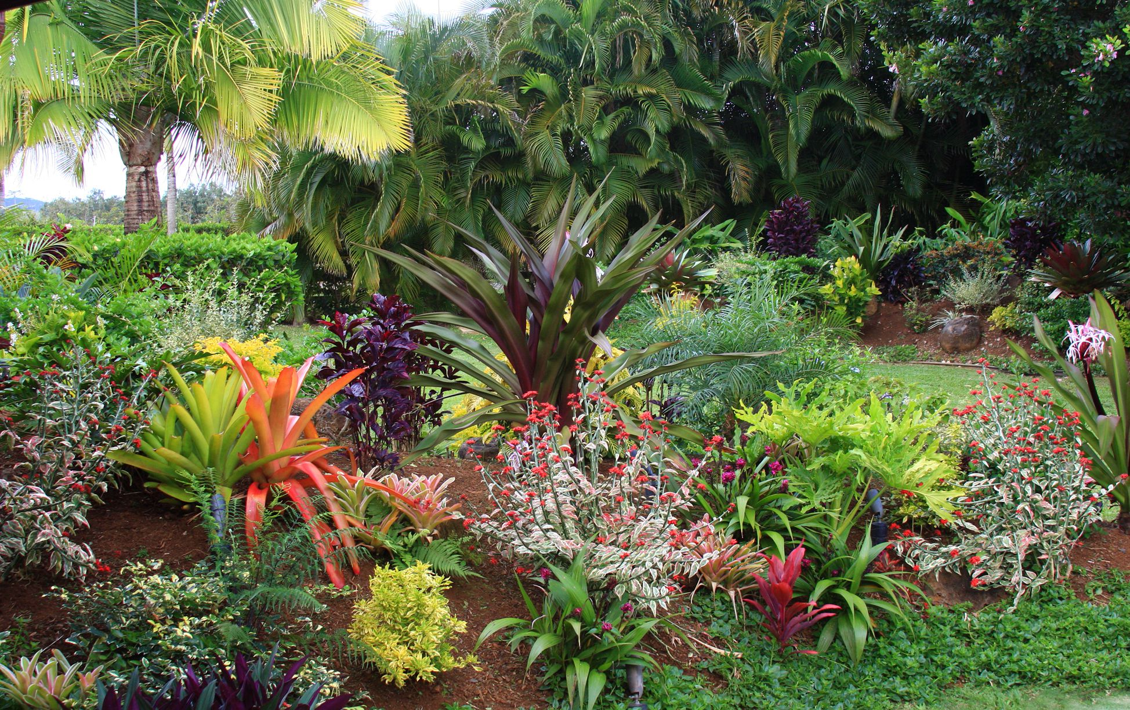

Candidate Name: Chevannese Ellis

Candidate Number: 1001520758

Course: Visual Arts

Instructor: Miss Hogarth

Institution: Mona High School

Mona Center: 100152

*Table of Contents*

Chapter One 4

Artist Statement 5

Definition of theme 6

History of Plant Life 6

Why is the theme inspiring? 7

Why you chose the theme? 8

Expressive Form One 9

Painting and Mixed Media 9

History of Painting and Mixed Media 9

Painting and Mixed Media Styles and Types 9

Painting and Mixed Media Materials 9

Painting and Mixed Media Techniques 10

Expressive Form Two 11

Textile Design and Manipulation 11

History of Textile Design and Manipulation 11

Textile Design and Manipulation Styles and Types 11

Textile Design and Manipulation Materials 11

Textile Design and Manipulation Techniques 12

Chapter Two 13

Artist of Inspiration One 14

Painting and Mixed Media 14

Some of Herbie Rose’s Artwork 15

Artist of Inspiration Two 17

Textile Design and Manipulation 17

Some of Katrina Coombs Pieces 18

Chapter Three 20

Elements of Art 21

Principles of Art 24

Chapter Four 27

### Chapter One

# Artist Statement

Plants with its various forms and species provide an abundance of ideas for an artist. The different seasons and color variants of plants define the beauty of it, which allows me to convey and express the different feelings and patterns that can be developed with plant life.

The theme that was selected for my School Based Assessment is “Plant Life”. I chose this theme because I love observing plants and all the diverse plants that you can discover. Art allows me to convey my feelings for plant life using different forms. I will use the different elements and principles of art to further express my theme and ardor for plant life.

# Definition of theme

Plant life are plants collectively, especially those native that belongs to a particular region, habitat, or geological period.

# History of Plant Life

The evolutionary history of plants is recorded in [fossils](https://www.britannica.com/science/fossil) preserved in lowland or marine sediments. Some fossils preserve the external form of plant parts; others show cellular features; and still others consist of microfossils such as [pollen](https://www.britannica.com/science/pollen) and [spores](https://www.britannica.com/science/spore-biology). In rare instances, fossils may even display the ultra-structural or chemical features of the plants they represent. The [fossil record](https://www.britannica.com/science/fossil-record) reveals a pattern of accelerating rates of [evolution](https://www.britannica.com/science/evolution-scientific-theory) coupled with increasing [diversity](https://www.merriam-webster.com/dictionary/diversity) and complexity of biological [communities](https://www.merriam-webster.com/dictionary/communities) that began with the invasion of land and continued with the progressive colonization of the [continents](https://www.britannica.com/science/continent). At present, fossil evidence of land plants dates to the [Ordovician Period](https://www.britannica.com/science/Ordovician-Period) (about 485.4 million to 443.8 million years ago) of the [Paleozoic Era](https://www.britannica.com/science/Paleozoic-Era). However, research using “[molecular clock](https://www.britannica.com/science/molecular-clock)” [methodology](https://www.merriam-webster.com/dictionary/methodology), which uses [genetics](https://www.britannica.com/science/genetics) to estimate how long [species](https://www.britannica.com/science/species-taxon) have been separated from a common ancestor, suggests that plants started to colonize terrestrial [environments](https://www.merriam-webster.com/dictionary/environments) around 500 million years ago, about the middle of the [Cambrian Period](https://www.britannica.com/science/Cambrian-Period).

# Why is the theme inspiring?

Plant life is inspiring to me because it is interesting and stunning in its own way. It makes everything a lot more colourful and gives beauty to life which can make the atmosphere gentle.

# Why you chose the theme?

I chose the theme because it helps me to tap into my creative mindset in order to make diverse pieces.

## Expressive Form One

# Painting and Mixed Media

Painting is the practice of applying paint, pigment, color or other medium to a surface (support base). Mixed media tends to refer to a work of visual art that combines various traditionally distinct visual art media.

# History of Painting and Mixed Media

Cave dwellers were the earliest artists. Colored drawings of animals, dating from about 30,000 to 10,000 B.C., have been found on the walls of caves in southern France and in Spain.  People had invented the basic tools and materials for painting. Techniques and materials were refined and improved in the centuries following.

# Painting and Mixed Media Styles and Types

1. Assemblage 2. Acrylic Painting

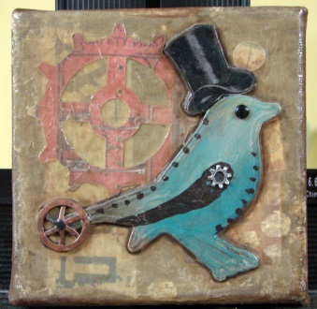 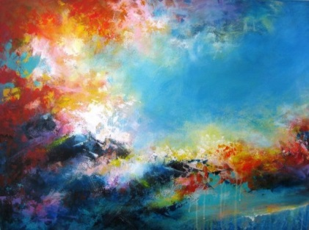

# Painting and Mixed Media Materials

1. Paint 3. Cartilage Paper

2. Paint Brush 4. Cardboard

5. Palette

# Painting and Mixed Media Techniques

1. Impressionism 2. Cubism

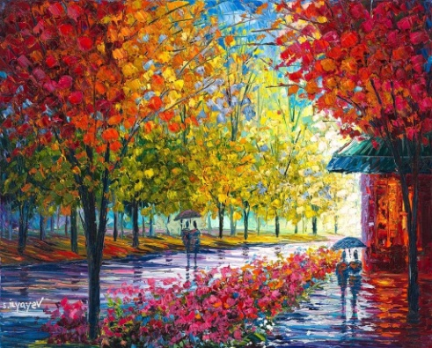 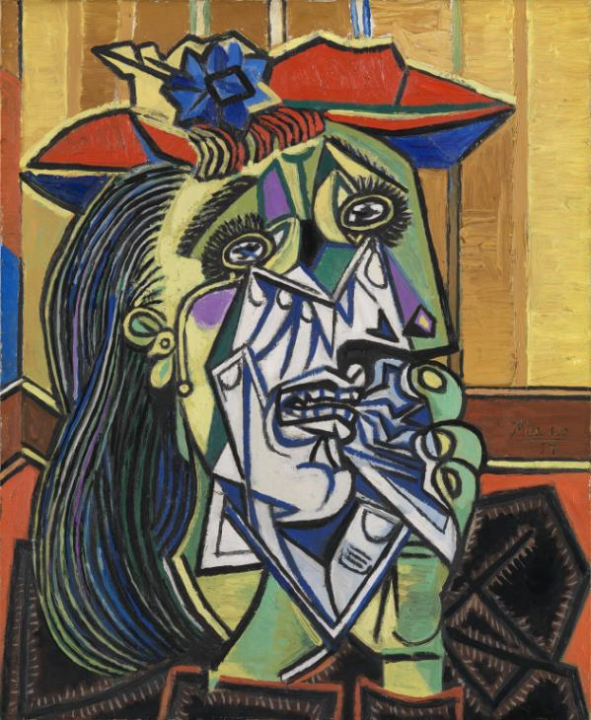

1. Mosaic 2. Photomontage

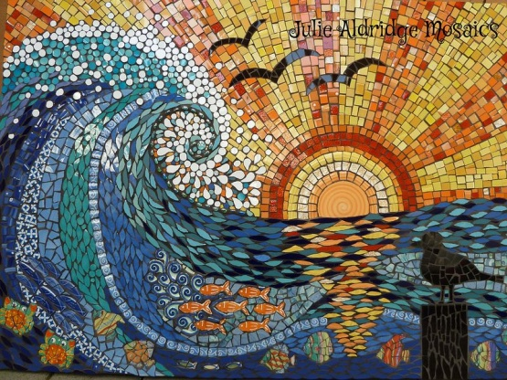 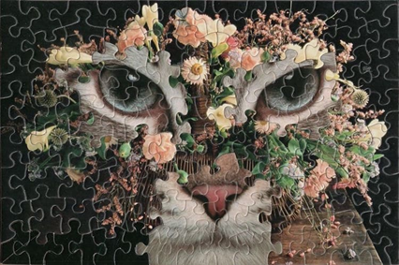

## Expressive Form Two

# Textile Design and Manipulation

Textile design is the process of planning and producing a fabric's appearance and structure. It uses plant, animal, or synthetic fibers to construct practical or decorative objects.

# History of Textile Design and Manipulation

The earliest were nets, produced from one thread and employing a single repeated movement to form loops, and basketry, the interlacing of flexible reeds, cane, or other suitable materials. The production of net has been practiced by many peoples, particularly in Africa and Peru. The earliest evidence of weaving, closely related to basketry, dates from Neolithic cultures of about 5000 BCE. Weaving apparently preceded spinning of yarn; woven fabrics probably originated from basket weaving. Cotton, silk, wool, and flax fibres were used as textile materials in ancient Egypt.

# Textile Design and Manipulation Styles and Types

1. Home Goods 2. Clothing Industry

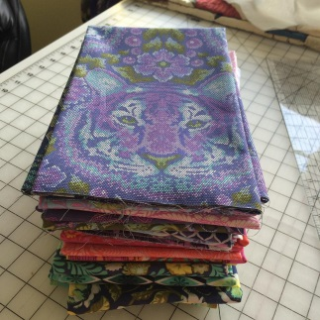 

# Textile Design and Manipulation Materials

1. Cloth/Fabric 3. Acrylic Paint

2. Thread or Yarn 4. Dye

5. Paintbrush

# Textile Design and Manipulation Techniques

1. Embroidery 2. Batik

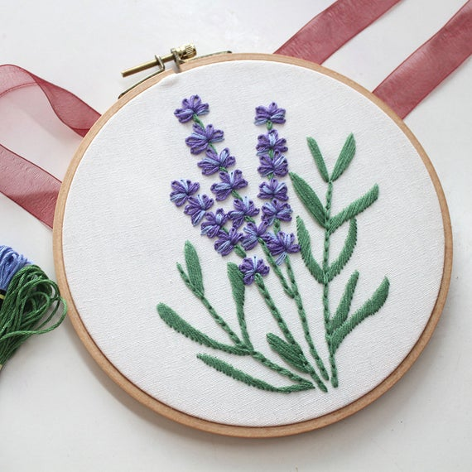 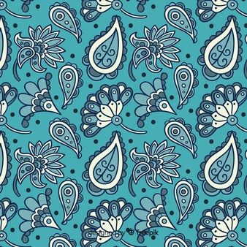

3. Tie – Dye 4. Appliqué

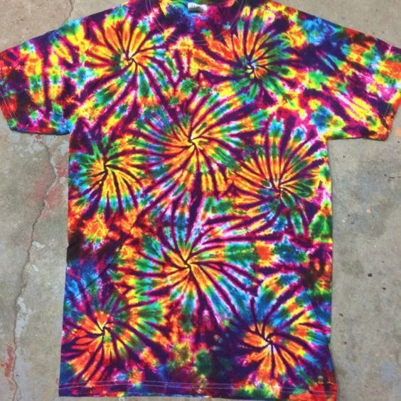 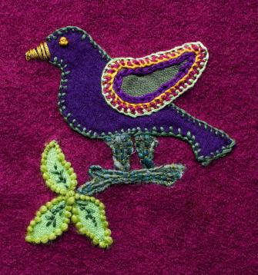

### Chapter Two

## Artist of Inspiration One

# Painting and Mixed Media

**Rose** was **born** in Jamaica in 1930. He was a Jamaican painter who studied at the New York Phoenix School of Design. Before he began to paint, he worked in advertising to build his design ability. He uses oils and acrylics to create his paintings. Mr. Rose opened his first gallery in the neighborhood that is now the Village of the Arts more than 30 years ago. He graduated cum laude from the New York Phoenix School of Design and took post-graduate courses at Pratt Institute. He worked in advertising before he opened his first gallery, in Jamaica. His art can be seen around the United States. He came to Bradenton in the mid-1980s. Herbie Rose, who is widely considered the founder of the Village of the Arts, passed away in 2017 after a prolonged illness.

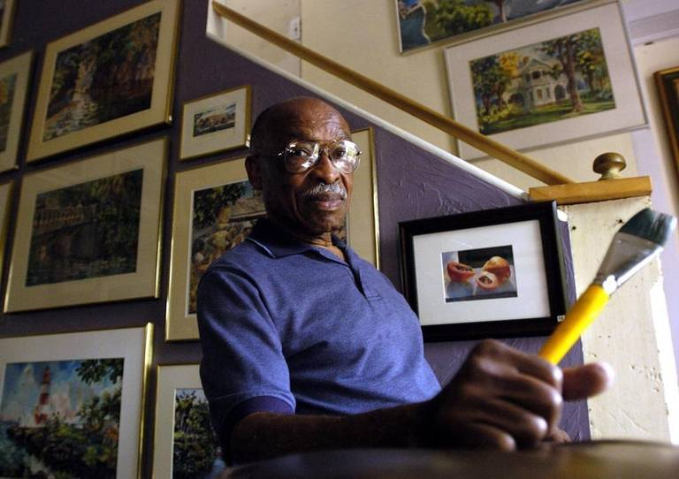

# Some of Herbie Rose’s Artwork

 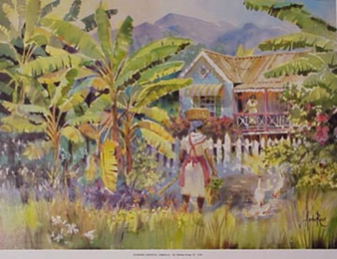

Name of Artist: Herbie Rose Name of Artist: Herbie Rose

Title: Dunn River, Jamaica Title: Banana Garden, Jamaica

Medium: Oil and Acrylics Paint Medium: Oil and Acrylics Paint

Size: 46cm x 61cm Size: 46cm x 61cm

Year: 1994 Year: 1994

 

Name of Artist: Herbie Rose Name of Artist: Herbie Rose

Title: Washday Title: Port Antonio

Medium: Oil and Acrylics Paint Medium: Oil and Acrylics Paint

Size: 46cm x 61cm Size: 46cm x 61cm

Year: 1988 Year: 1994



Name of Artist: Herbie Rose

Title: Lady With Baby

Medium: Oil and Acrylics Paint

Size: 46cm x 61

Year: 1982

## Artist of Inspiration Two

# Textile Design and Manipulation

Katrina Coombs was born in 1986, in Kingston, Jamaica. She holds a BFA with honours in Textile and Fibre Art (2008) and a Certificate in Curatorial Studies (2009) from the Edna Manley College of the Visual and Performing Arts. In 2013, she obtained an MFA in Creative Practice from the University of Plymouth in the UK, via Transart Institute in New York, USA. Coombs’s work has been featured in many exhibitions since 2008, including the School of Visual Arts Faculty Shows at the CAG[e] Gallery, Edna Manley College from 2009 to 2016 and she was one of the young artists featured in Young Talent 2015 at the National Gallery of Jamaica. She also participated in Dimensions of Womanhood at the 2016 Kingston on the Edge Urban Arts Festival.

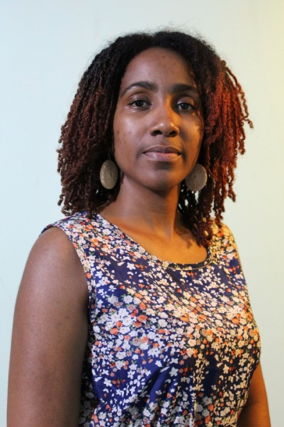

# Some of Katrina Coombs Pieces

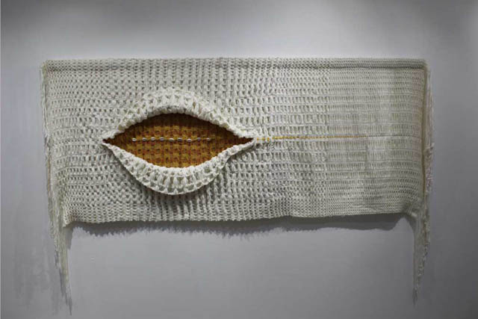 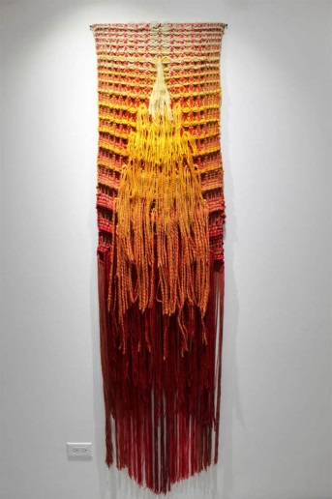

Name of Artist: Katrina Coombs Name of Artist: Katrina Coombs

Title: As it Breathes Life, Life is Taken Title: Her Constellation

Medium: Hand woven mixed fibers and cowrie shells Medium: Woven mixed fibers and cowrie shells

Size: 68.5 x190.5 cm (27 x 75 in) Size: 213.3 x 55.8 cm (84 x 22 in)

Year: 2020 Year: 2020

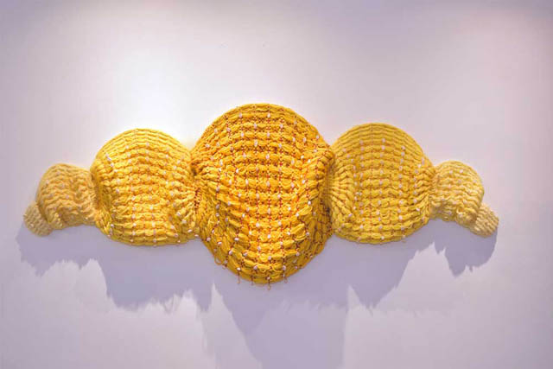 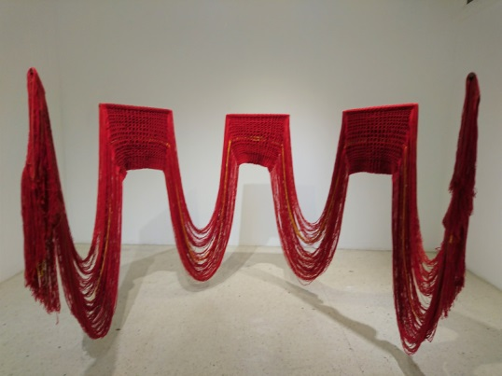

Name of Artist: Katrina Coombs Name of Artist: Katrina Coombs

Title: Armour of the Other Title: Golden Flow

Medium: Hand woven mixed fibers and cowrie shells Medium: Hand woven mixed fibers

Size: 116.8 x 195.5 cm (46 x 77 in) Size: N/A

Year: 2020 Year: 2018

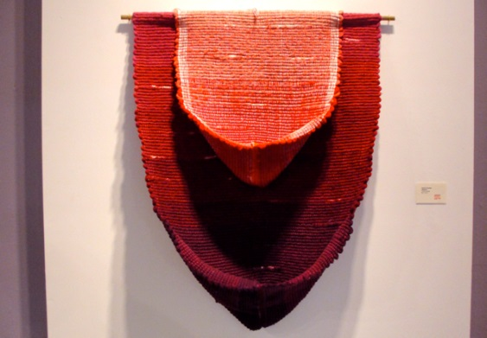

Name of Artist: Katrina Coombs

Title: Absence

Medium: Woven Mixed Fibers

Size: N/A

Year: 2014

### Chapter Three

# Elements of Art

Line

Line is the path of a point moving through space. It may be two-or three-dimensional, descriptive, implied, or abstract.

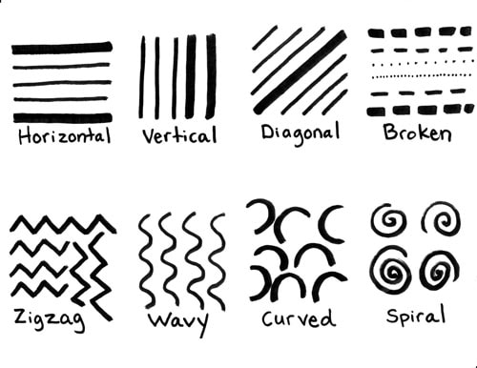

Shape

An element of art that is two-dimensional, flat, or limited to height and width.

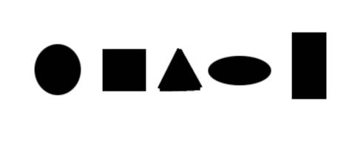

Form

This is an element of art that is three-dimensional and encloses volume which includes height, width and depth.

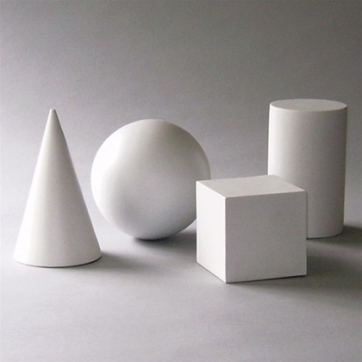

Value

This element represents the lightness or darkness of tones or colors. White is the lightest value; black is the darkest. The value halfway between these extremes is called middle gray.

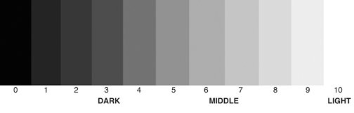

Texture

This element of art that refers to the way things feel, or look as if they might feel if touched.

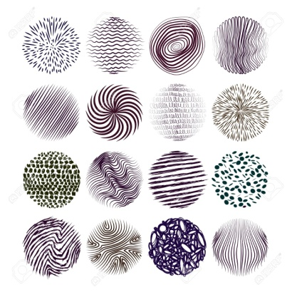

Colour

An element of art made up of three properties: hue, value, and intensity.

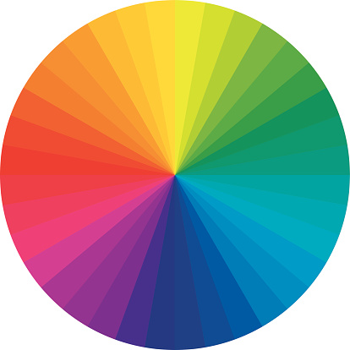

Space

The element of art refers to the distances or areas around, between, and within components of a piece.

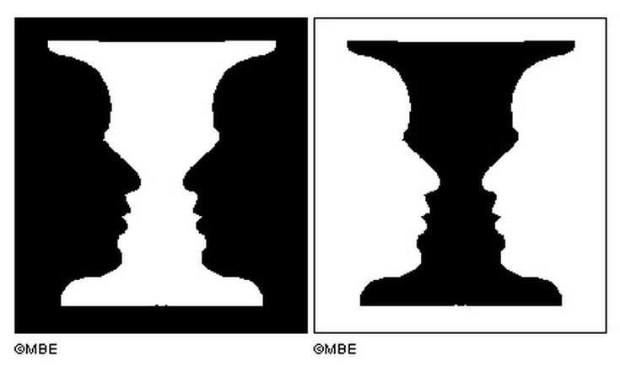

Dot

A **dot** marks the beginning and the end of a line.

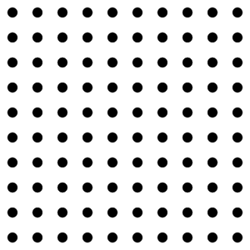

# Principles of Art

Balance

This principle of art combines elements to add a feeling of equilibrium or stability to a work of art.

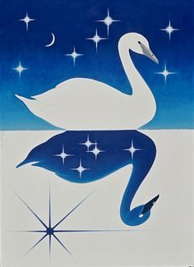

Variety

A principle of design concerned with diversity or contrast. Variety is achieved by using different shapes, sizes, and/or colors in a work of art.

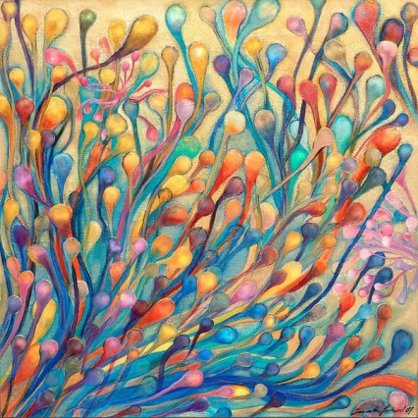

Contrast

It is the way of combining elements to stress the differences between those elements.

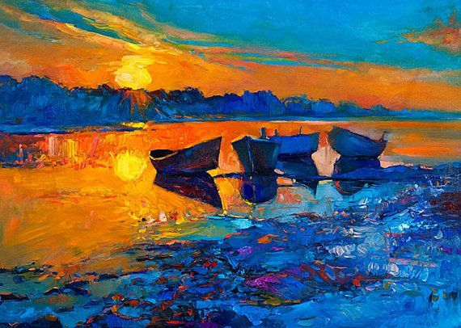

Rhythm

It is the principle of design which indicates movement that is created by the careful placement of repeated elements in a work of art to cause a visual tempo or beat.

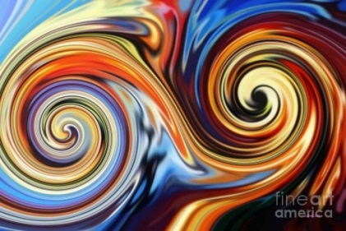

Harmony

The quality of how the visual elements are working together in a composition. It is achieved when all elements have unity and cohesion, giving a sense of completion to an **artwork**. This does not mean that all elements have to be the same, but they must relate to each other in a purposeful way.

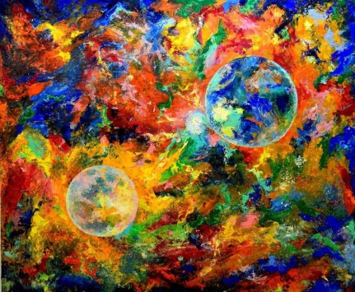

Proportion

It is the comparison of dimensions or distributions of forms. It is the relationship in scale between one element and another, or between a whole object and one of its parts.

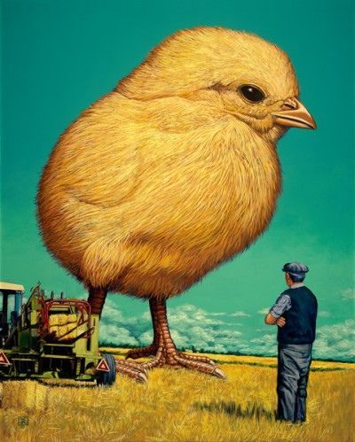

Emphasis

Emphasis refers to the created center of interest, the place in an artwork where your eye first lands.

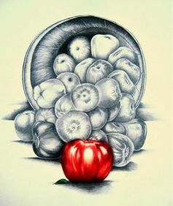

Pattern  
Pattern refers to the repetition or re-occurrence of a design element, exact or varied, which establishes a visual beat.



### Chapter Four